Healthcare Management System

1. **Creating the tables**

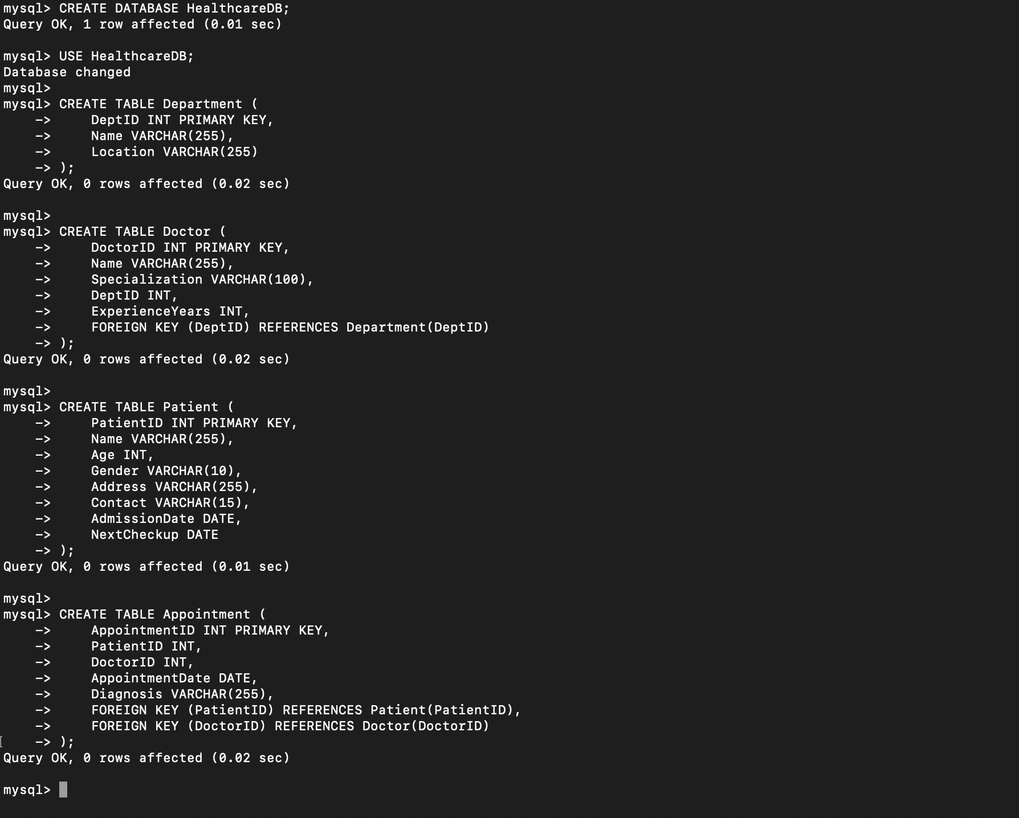

1. **Inserting sample data**

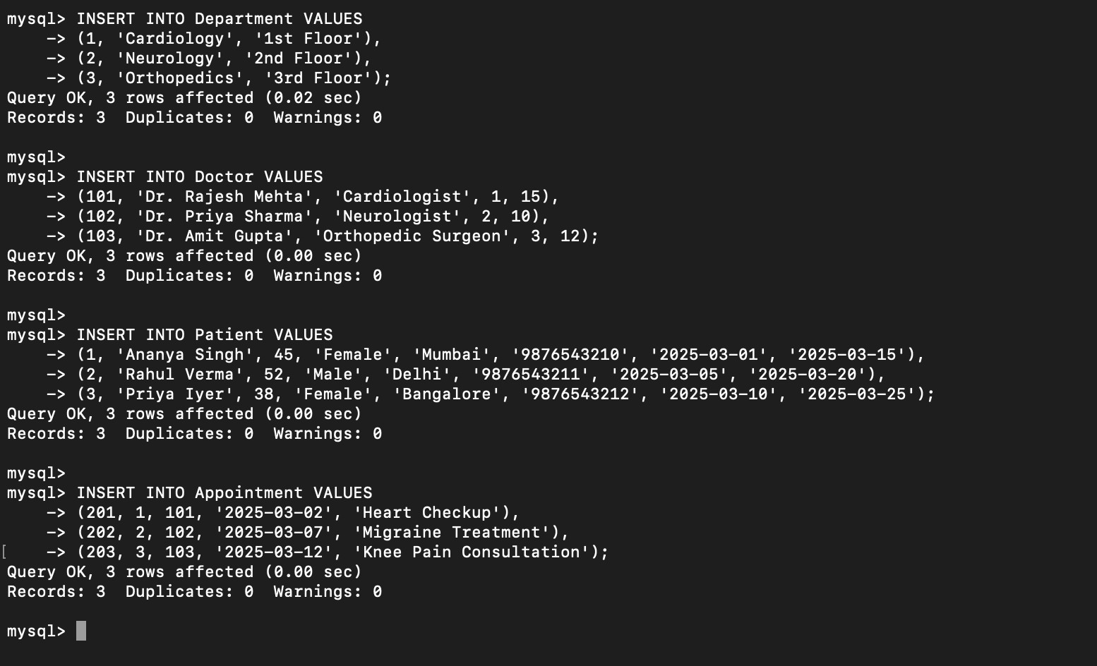

1. **Retrieve details of all admitted patients**

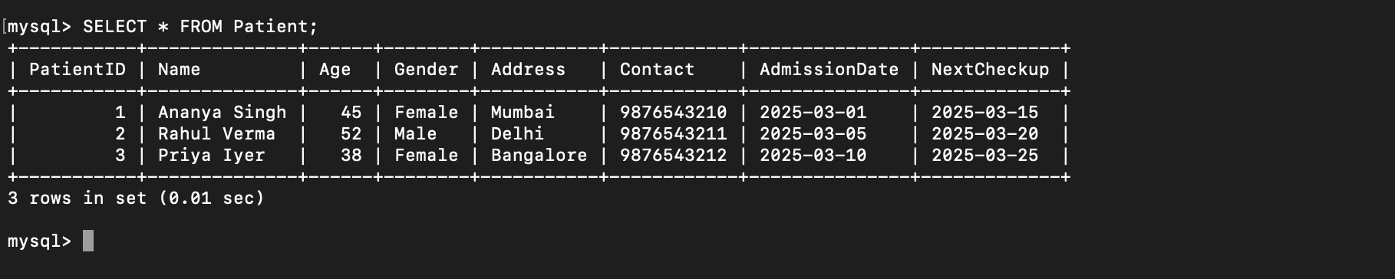

1. **Find the most consulted doctor in the last 6**

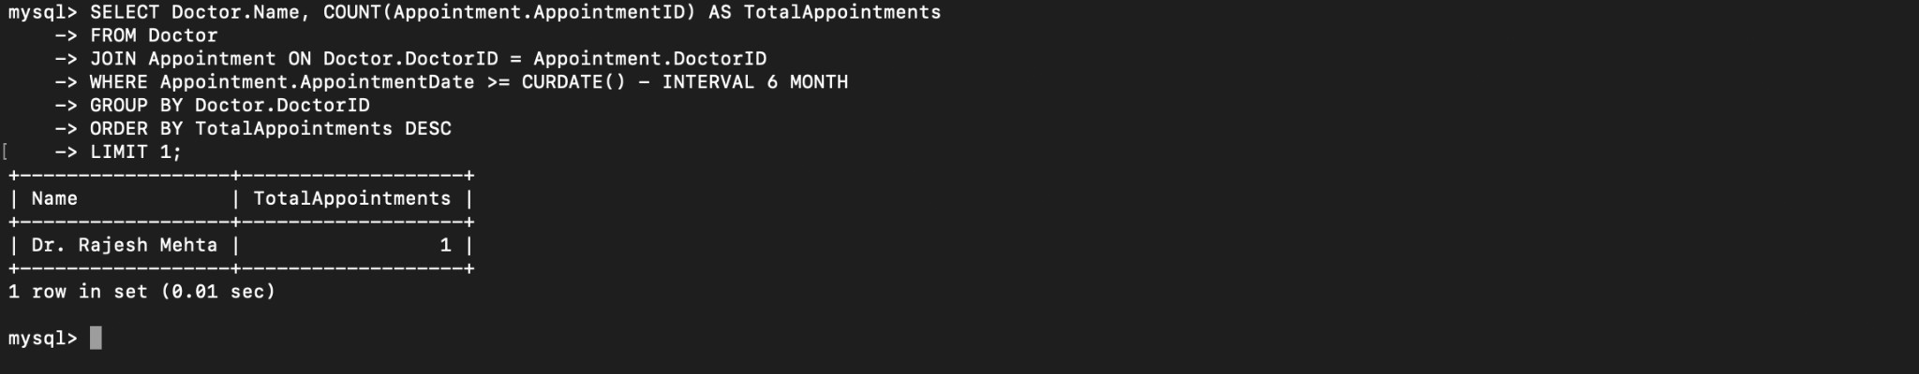

1. **Retrieve all appointments for a specific doctor**

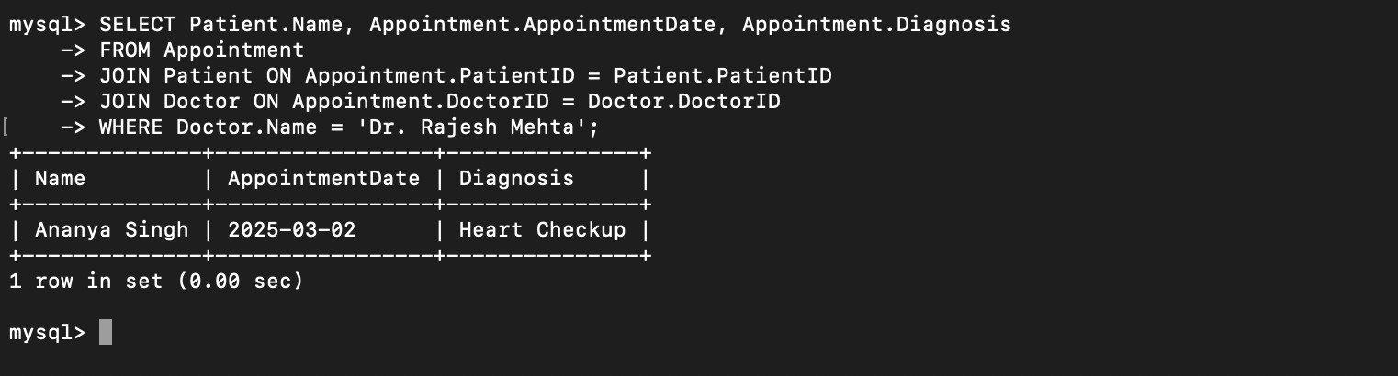

1. **Find the department with the highest number of patients**

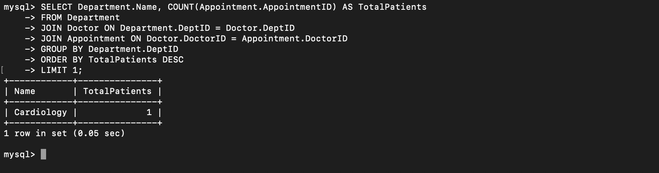

1. **Display all patients whose next checkup is within 7 days**

